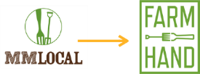
News Release
For Immediate Release

Contact: Emily Smith
303.903.4970
emily@freshideasgroup.com

Goodbye MM Local, hello Farmhand Organics
Regional organic food manufacturer changes identity to better reflect mission

WESTMINSTER, Colo. (Nov. 8, 2017) – The only thing MM Local isn’t preserving in 2017 is its name. The eight-year-old Colorado company, on a fast-track for growth and expansion, announced today it is changing its name from ‘MM Local’ to ‘Farmhand Organics.’ The pioneering farm-to-fork brand is launching new packaging across all of its certified organic product lines, beginning with its popular probiotic line of sauerkrauts and kimchis.
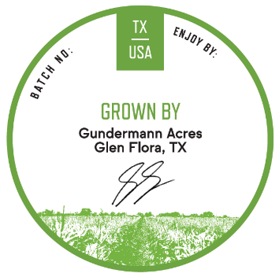
The renamed Farmhand Organics has the same mission: its transparent relationship with certified organic farmers to make the highest quality farm-to-jar products for today’s conscious and health-driven consumers. All Farmhand Organics products still include its signature traceability sticker that shows the consumer exactly which farm grew the produce for that specific product.
Farmhand Organics buys directly from 15 organic family farms across the U.S., with plans to expand its roster of organic family farmers and expand its product sales to more retailers throughout the country.

“It’s been a good partnership. We like to see our farm’s product reach a wider audience year round and knowing other people around the country are enjoying our product, too,” said Dave Asbury, of Full Circle Farms in Longmont, Colo., who has sold cucumbers, cabbage, beets and peppers to MM Local since 2009.

“While representing less than 1 percent of agricultural output in the country, we believe it is these family farms that are most important to building healthier and more sustainable local food systems across the country,” said Mills. “A handshake has always been the most important contract to us.”

Farmhand’s certified organic product lines are small-batch made jarred goods including pickled vegetables, apple and pear sauces and its best-selling probiotic line of sauerkrauts, kimchis and hot sauces. Studies show these “naturally probiotic” products contain live active cultures and good bacteria to promote a healthy microbiome and strengthen immune and digestive systems.
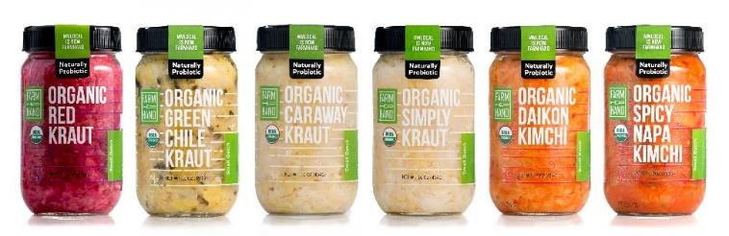
The market for probiotics is projected to exceed $63 billion by 2022 and the global organic food and beverage market is expected to reach $320.5 billion by 2025. These statistics align with Farmhand Organics’ sales trends as its probiotic line of six product SKUs is the company’s swiftest growing category.

New name, new look, same delicious farm-to-jar products.

Farmhand Organics’ new name is also intended to eliminate confusion for consumers and align with its core value of farm-to-fork quality and transparency: the jarred goods will become even more transparent with more space on the jar to allow the natural hues of fruits and vegetables to ‘pop.’

Farmhand Organics recently donated $1,650 to its partner growers at Gundermann Acres in Glen Flora, Texas, whose farm was devastated by Hurricane Harvey this August. The donation was matched by Whole Foods Market for a total of $3,300.

“I’m looking at washouts knee deep from the water running through it. My house got flooded, too,” said Garrett Gundermann. “I’ve gotten about $500 from the state but that’s it. There hasn’t been a whole lot of help from anybody. MM Local donated a percentage of sales with Whole Foods Market to match and that will be the biggest help I’ve received.”

Farmhand Organics’ transparency and support will remain the same, allowing its relationships with organic family farmers across the country to thrive, and growing its support for more farmers.

“We built our company on a foundation of quality local food sourced from organic family farms we are proud to partner with,” said Jim Mills, founder and CEO of MM Local, now Farmhand Organics. “We are excited to have a new name and brand that starts to tells our story while broadening our horizon for reach, impact and growth.”

MM Local started with three products – Farmhand Organics now has over 20 products in the marketplace, with the goal of making delicious, quality farm-to-jar food available year round.

Farmhand Organics products are currently sold at natural and conventional retailers under the MM Local name and will be transitioning new packaging to stores beginning with the probiotic line of sauerkrauts and kimchis in November 2017; and nationally at www.farmhandorganics.com by the end of November 2017. Additional MM Local products including apple and pear sauces and pickled fruits and vegetables will be sold under the Farmhand Organics label beginning in 2018.

Suggested retail price for Farmhand Organics products range from $4.99 to $9.99, with the probiotic line of sauerkrauts and kimchis priced from $7.29 to $8.69.

###

About Farmhand Organics (formerly MM Local)

Based in Westminster, Colo., Farmhand Organics is a values-based company that cares deeply about farms, families and their communities. With a mission to promote high-quality, farm-to-fork local food, the company started selling its original MM Local products at farmers markets and locally grocery stores in 2009. Farmhand Organics is built on a foundation of transparency and supporting organic family farms, and works directly with certified organic farms across the U.S. to produce its apple and pear sauces, kimchis, pickled vegetables and sauerkrauts. Each jar includes a Farm Traceability sticker, complete with the farmer’s signature, on the top of the lid, identifying the exact farmer whose produce was used in the making of that specific product. Farmhand Organics offers more than 20 pickled, preserved, and naturally probiotic products including sauerkraut, kimchi, fruit sauces and pickled vegetables. For more information visit www.farmhandorganics.com.

